**Name:**Om Raut

**Designation-**Devops Engineer

**Task 1: Git & GitHub Basics**

**🎯 Objective**

The objective of this task is to understand and practice the basics of Git and GitHub, including repository initialization, pushing code to GitHub, and working with branches using Pull Requests.

**📝 Steps Performed**

**1. Initialize a Git Repository**

* Created a new local folder Devops-task.
* Initialized a Git repository:

git init

* Added project files and committed the initial changes:

git add . git commit -m "Initial commit"

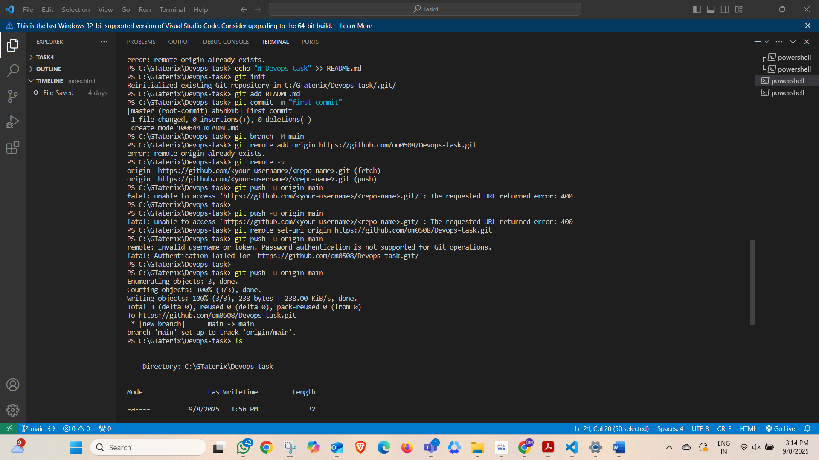

**2. Connect to GitHub and Push Code**

* Created a new repository on GitHub: **Devops-task**.
* Added remote origin:

git remote add origin https://github.com/om0508/Devops-task.git

* Set main branch and pushed the code:

git branch -M main git push -u origin main

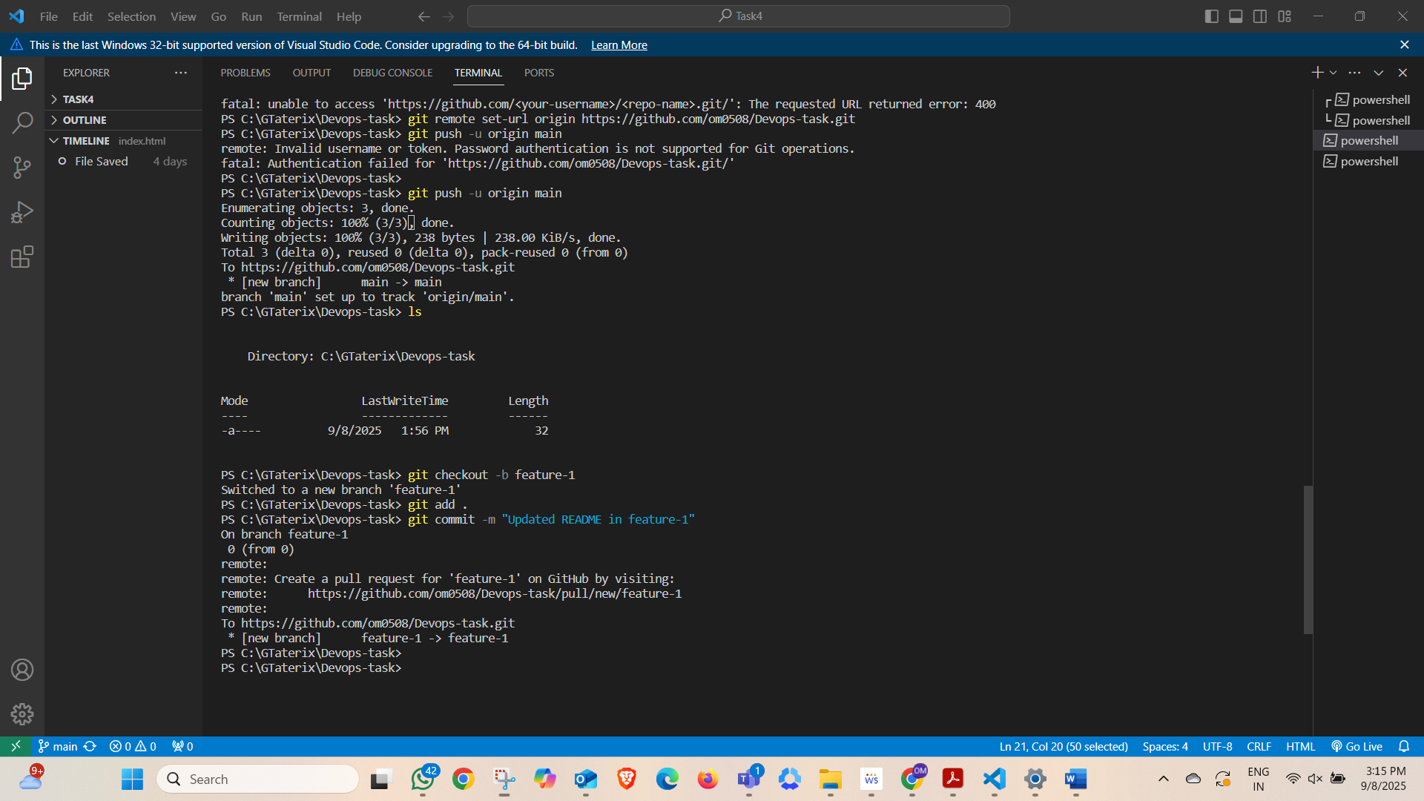

**3. Create a Feature Branch and Pull Request**

* Created a new branch:

git checkout -b feature-1

* Made changes to README.md and committed them:

git add . git commit -m "Updated README in feature-1"

* Pushed feature branch:

git push origin feature-1

* Opened GitHub → Created a Pull Request (PR) → Merged into main.  
  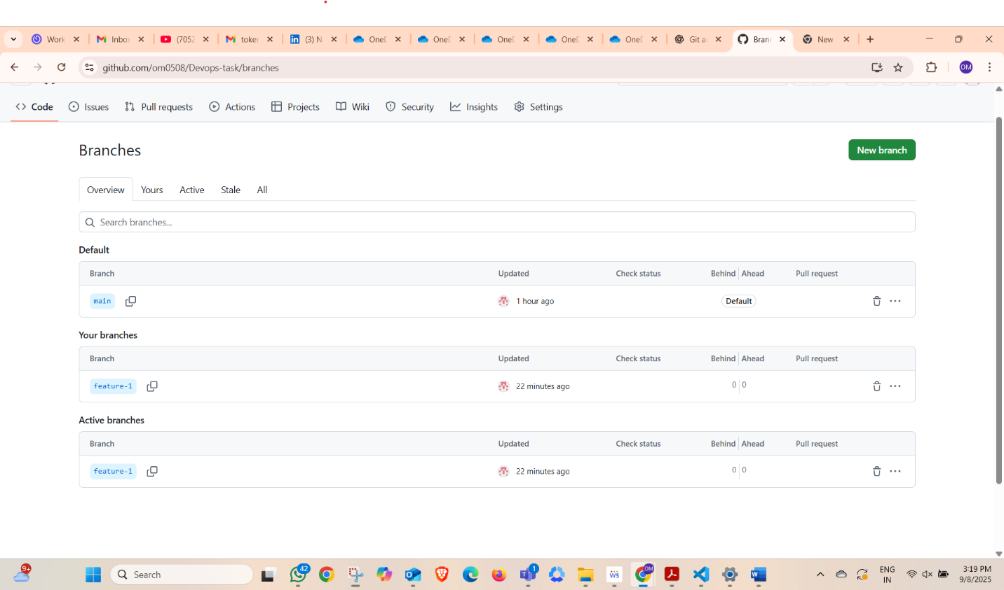

**✅ Outcome**

* Successfully initialized and pushed a repository to GitHub.
* Learned how to create and manage branches.
* Understood the workflow of **Pull Requests (PRs)** and merging.